

**FAST NATIONAL UNIVERSITY**

OF COMPUTER AND EMERGING SCIENCE.

*(KARACHI CAMPUS )*

*DB PROJECT REPORT:*

***“PET SITTING”***

**SUBMITTED BY:**

ALAINA USMANI (21K-3155)

AREEBA HASSAN (21K-4855)

SALEHA ZAINAB (21K-4918)

Introduction:

The Pet sitting is a comprehensive web-based platform that aims to facilitate the adoption and financial support for pets in need. The goal of this project is to develop an easy-to-use and effective platform that links animal lovers with companion animals that are in need of foster care or financial support. Users can choose between adoption and donation pages, select pets, and perform actions such as adoption requests and monetary donations. The system includes user authentication, an admin interface, and database management.

Objectives:

* Unified Platform: Provide a centralized platform for both pet adoption and financial contributions.
* User Engagement: Enhance user engagement through personalized accounts and interactive features.
* Admin Approval System: To guarantee responsible pet ownership, implement an admin approval system for adoption requests.
* Secure Transactions: Enable secure credit card transactions for safe financial contributions.
* Transparency: Maintain transparency by updating users on the total amount collected for each pet.
* Admin interface: Provide an admin interface for managing pets and user requests.
* Data management: Maintain a database to store user information, pet details, and transaction history.

Features:

* Adoption Page: Allows users to explore and choose pets for adoption based on preferences.
* Donation Page: Provides a platform for users to contribute funds to pets in need.
* User Authentication: Ensures secure login and account creation for personalized experiences.
* Admin Approval System: Admins review and approve adoption requests, ensuring responsible pet ownership.
* Transaction Security: Implements secure credit card transactions for financial contributions.
* User History: Enables users to view their adoption and donation history.
* Pet Management: Admins can add, modify, delete pets for adoption and donation. Include details such as pet type, breed, age, health status, and a brief description.

System Architecture:

* Front-End: Developed using HTML, CSS, and JavaScript for a visually appealing and responsive user interface.
* Back-End: Utilizes PHP and MySQL for robust database management, user authentication.

Detailed Working:

User Perspective:

1. Homepage:

Users open the website and are greeted with a user-friendly homepage.

They have the option to choose between the Adoption Page or Donation Page.

2. Adoption Page:

Users exploring the Adoption Page can:

View detailed profiles of available pets, including breed, age, and health status.

Select a pet for adoption, initiating the adoption process.

3. Donation Page:

Users visiting the Donation Page can:

Choose a pet to support financially.

Specify the donation amount and proceed to a secure payment gateway.

4. User Authentication:

If not already logged in, users are prompted to log in or create an account.

User authentication ensures secure interactions and personalized experiences.

5. Adoption Process:

After selecting a pet for adoption, users submit an adoption request.

Admins review the request and, upon approval, the pet is marked as adopted.

Users can view their adoption history to track successful adoptions.

6. Donation Process:

Users, after selecting a pet for donation, enter a donation amount.

Secure credit card transactions are implemented for financial contributions.

The system subtracts the donated amount from the total required, updating the progress.

If the total amount is reached, the pet is removed from the Donation Page.

7. User History:

Users have access to a personal dashboard where they can view their adoption and donation history.

Admin Perspective:

1. Admin Authentication:

Admins log in using unique credentials, ensuring access control.

2. Pet Management:

Admins can add new pets, update pet information, and delete pets.

3. Adoption Request Approval:

Admins review adoption requests submitted by users.

They have the authority to approve or reject requests, maintaining responsible pet ownership.

4. Donation Management:

Admins monitor the funds raised for each pet.

Real-time updates on the total amount received and the remaining amount needed.

5. User Management:

Admins view user profiles and details.

10. System Logs:

Admins review logs of user activities, adoption requests, and system events.

ERD:

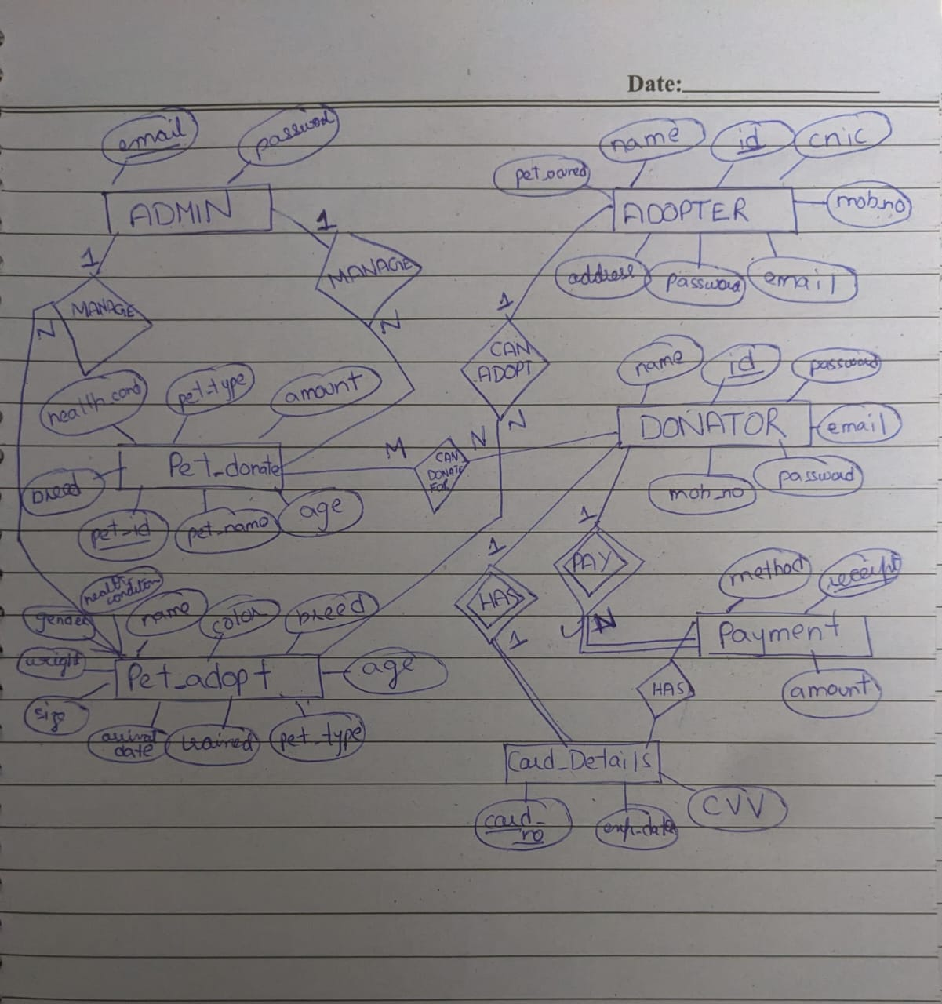

Normalization:



